Teaching Without PowerPoint
There is a saying that to a child with a hammer, the whole world looks like a nail. I would like to suggest an update to that, to a tutor who needs to teach students, everything looks like a PowerPoint presentation.
This year I have decided to make a radical change in my teaching – I have decided to eliminate PowerPoint in my synchronous teaching. I still use some pre-recorded presentations, but my ‘live’ teaching, both face-to-face and online, has used NILE, not PowerPoint.
I have managed this change by using folders. Every taught session has its own folder. The front of each folder contains details of the session, including the session learning goals, pre-session activities, session activities, and post-session activities.
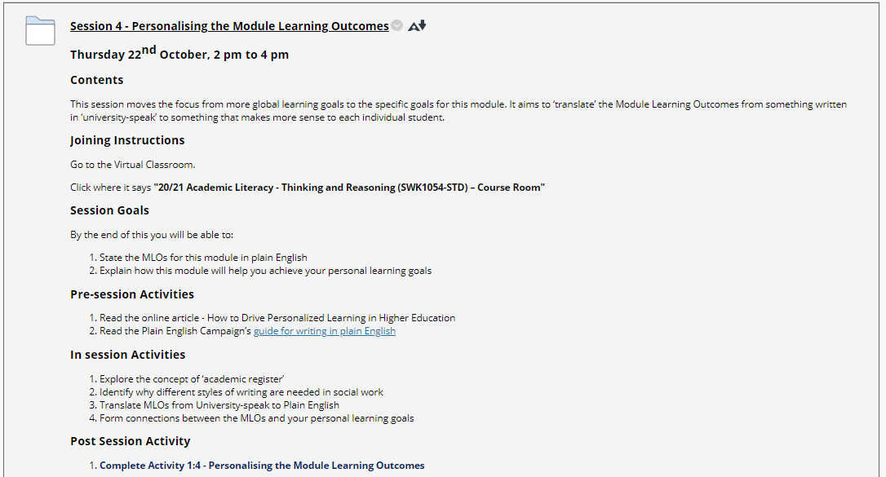
Figure 1- Example of a Session Folder
To avoid the folders getting overly crowded, there are three sub-folders, one for the pre-session activities, one for the session activities, and one for the post-session activities.
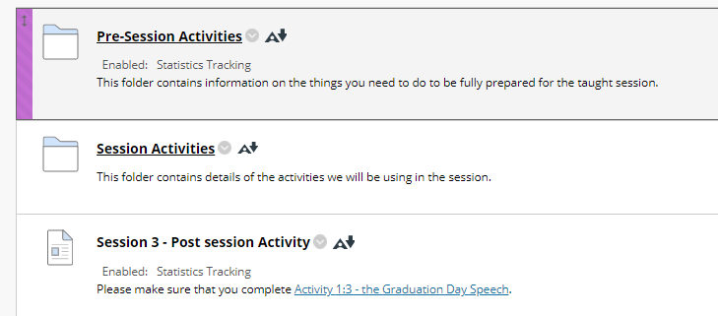
Figure 2 - Sub-folders within a session folder
In the session folder, material is broken down into Teaching elements and Activities.
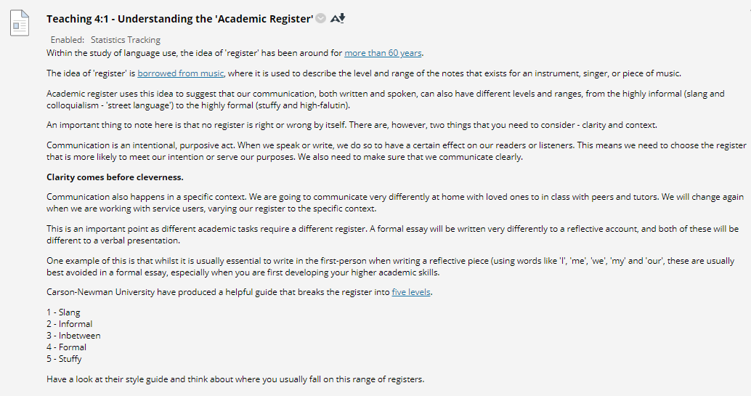
Figure 3 - Example of a Teaching Element
A key part of this approach is that students are encouraged to bring internet accessible devices into the classroom and have them logged onto the NILE site during the session, or to have the relevant Session open alongside the Blackboard Collaborate window if they are joining remotely. In Figure 3, you can see how there are hyperlinks to encourage students to check out what I have written. You can also incorporate images, as is shown in Figure 4.
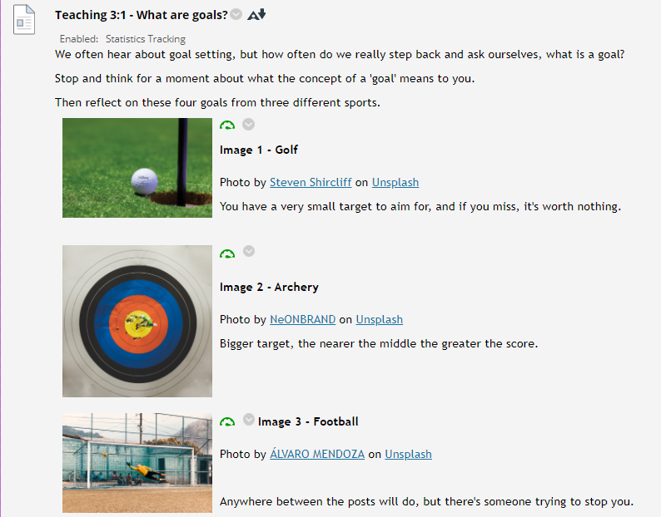
Figure 4 - Use of images in teaching material
Activities are interspersed with the teaching to support students in actively applying the teaching. This helps students develop a deeper understanding of the taught material. These can incorporate things like worksheets and work well when students are working in smaller groups (see figure 5 for an example).
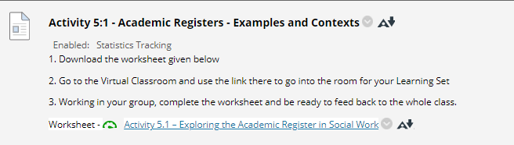
Figure 5 - Example of an Activity
Although Blackboard Collaborate does allow for the use of Breakout Rooms, I have found it better to organise these in advance, as shown in figure 6. 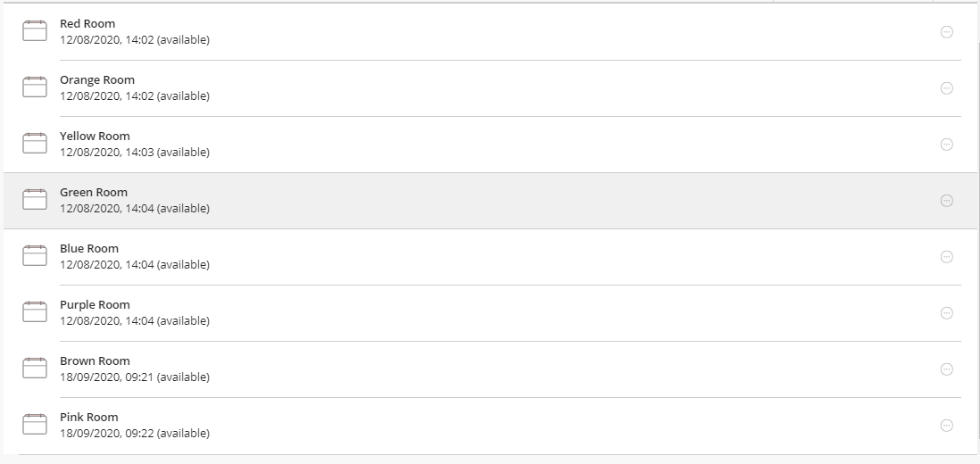
Figure 6 - Example of pre-set Breakout Rooms
Using pre-set Breakout Rooms makes it quick and easier to get groups to work together. They simply mute their microphones, keep the main module room open and join their group rooms. As the tutor, I mute the microphone in the main room and visit each of the rooms in turn, much the same as I would visit each table in a classroom. Once the allotted time has finished, I unmute the microphone and call all the students back into the main room for the next part of the session. Where the teaching has a face-to-face element, this allows students who are unable to physically attend to join with those who are in the room.
It is early days, and I am still learning skills in how to make things work as smoothly as possible, however I think this works better than presenting a PowerPoint slide show. Research shows that people pay attention to faces. This means that when students can see a tutor’s face, they are more likely to engage with the material being taught. If we are honest, most PowerPoint presentations are boring. Instead, well prepared material can act as an object of shared attention between tutor and student, thus encouraging a more active engagement with the material.
At this point, four weeks into the year, I do not know if this will yield the results I am hoping for, but so far, losing PowerPoint seems to be working well.

