Creating accessible documents

1. What
Documents and files that we use have to be accessible. There are three main principles:
- the structure of the document enables readers to navigate and access content using their preferred tools (e.g. screen readers, keyboard only);
- the content of the document is logical and presented clearly (e.g. colour contrast, font choices);
- providing alternatives where the original format may exclude some users (e.g. transcripts, image descriptions / Alt text).

2. Why
In addition to current legislation, there is a need to ensure that materials are accessible to anyone that needs them. Creating accessible documents actually benefits everyone rather than just people with particular needs.

3. When
There has always been a need to make documents accessible but the current legislation means a renewed focus from September 2019.

4. Who
This applies to anyone who produces documents.

5. How
The process for creating accessible materials varies depending on the type of document being created.

5.1) Microsoft Documents (Word, PowerPoint and Excel)
Just click on Review – Check Accessibility before you save the document and it will list any problems it can find and provide assistance on fixing these.
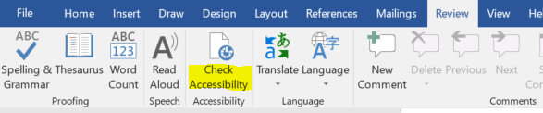
You can also manually correct some issues such as adding Alt text to an image by right clicking on the image and selecting “Edit Alt text”.

5.2) Videos
Upload the video to Kaltura. Subtitles will be automatically generated but will need checking for accuracy. If you need high quality (person generated) subtitles then mail learntech@northampton.ac.uk.

5.3) NILE / Blackboard
If you have uploaded documents into NILE / Blackboard then Ally will perform an accessibility check, provide an accessibility score, and provide alternative formats for the document for those accessing it.

5.4) PDFs
If you create an accessible Microsoft document then the PDF you create from that will also be more accessible. If you scan a document as a PDF then you also need to be aware that the document will also need to be made accessible. In both cases within Adobe Acrobat then click on Tools, Accessibility to open the accessibility tool bar which will allow for a “Full Check”.
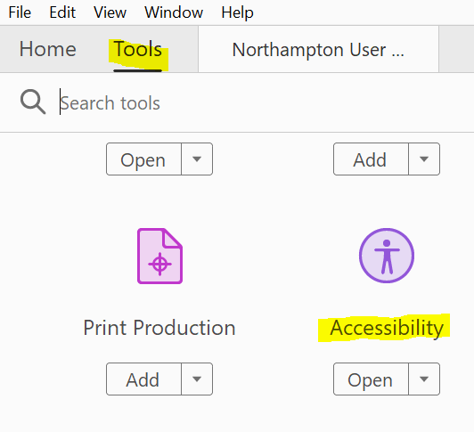

5.5) Other systems
Other systems vary on how to make documents accessible. Look at the help available for the tool you are using.

6. More help and advice
6.1 Have a look at the Universal design and creating accessible documents site on NILE for more guidance on creating accessible documents.
6.2 Review the UoN accessibility Guidelines produced by ASSIST
6.3 Review the video on Creating Accessible Documents in Microsoft Office, (25 mins). In particular look at Using Heading Styles in Word (1m 26s) as use of headers is not picked up by the Microsoft accessibility checker.

