CONTACT |  | Dr Terry Tudor  Senior Lecturer and Module Leader ENVM021
CONTEXT |  | ENVM021: Environmental and Waste Management Legislation is as the name suggests, a Masters’ level module focusing on environmental management legislation. It’s taught to both standard (i.e. face-to-face) and distance learning (DL) students. Given the nature of the subject matter (legislation), the materials are heavily text based, and delivered via Northampton Integrated Learning Environment (NILE).
INTENDED OUTCOMES |  | The initial intention was two-fold, namely to: (1) flip the classroom and get the students to do some background/more in-depth reading; and (2) facilitate discussion during the lectures.
THE PROCESS |  | For the 2014/5 academic year, it was decided that there was a need to find different ways of engaging the students with the materials, beyond the ‘traditional’ teaching and learning (T&L) approaches such as use of Power Point and case studies. E-tivities were therefore introduced, to run in conjunction with these traditional approaches. In addition, there were also role play opportunities where students were encouraged to argue for or against a judgement. Thus a range of T&L approaches was employed.  The e-tivities covered a range of factors. For example, students were asked to find a piece of legislation (thus directing them to searching NELSON), identify and critique relevant legislation, and also to examine the advantages and disadvantages of legislation in various contexts.  A key point to mention is that the cohort size was small. There were only three DL students and four standard students.
THE BENEFITS & CHALLENGES |  | 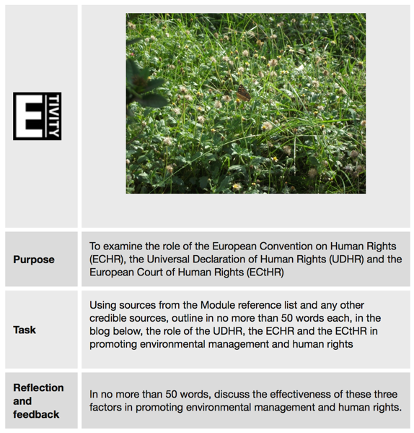  Placeholder for image  None of the students had used blogs before. They were mentioned in lesson 1 and introduced from lesson 2, and by lesson 3 the students were all comfortable with using them. An interesting occurrence after lesson 2 was receiving the responses to the activities by email, from a student, because they didn’t want to be the first to post.  Use of e-tivities enabled students to practice and hone their writing skills. In addition, because they had only a set number of words (usually about 50), they were forced to be succinct in getting their points over.  Perhaps most crucially, their responses were discussed during the lecture, thus they had immediate feedback on what they had written.  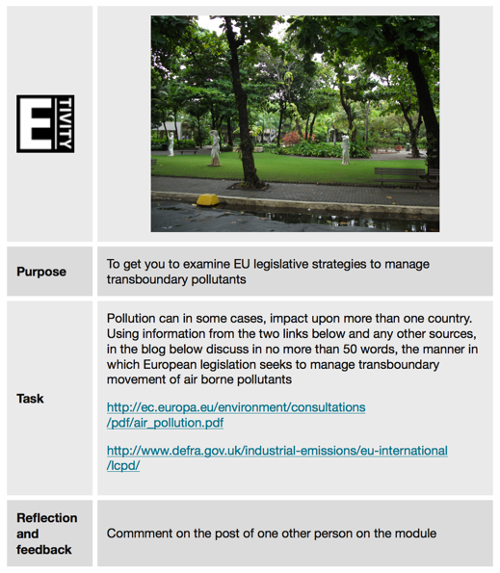  In addition, an unexpected ‘benefit’ was an improvement in the grammar of the students. A good example of this was one international student, whose first language wasn’t English and whose first post contained several grammatical errors. This issue of the student’s grammatical errors was raised during one of the discussions (incidentally, by another student). However, the transformation was such, that the student got an A for their first assignment, complete with very few errors.  Placeholder for image  It enabled both DL and standard students to ‘interact’. For example, they could and were encouraged to comment on each other’s work. Students enjoyed seeing and hearing what others had done. The small cohort size undoubtedly helped in that it was possible to go through each student’s responses. A large cohort would have required selection of a sample.  A ‘challenge’ was that students made mention of the balance between doing the e-tivities and also their formal assignments. The e-tivities weren’t graded and they felt given the amount of effort they were putting into them, there should be some reward. As a result, the second assignment was rewritten and based on the students utilising some of the material from the e-tivities, coupled with a reflective piece.
KEY POINTS |  | The top 3-5 takeaways from what I’ve learned:  - Ensure that the e-tivity is well defined and with clear instructions  - If students can see the relevance, they will participate, whether or not it’s for formal assessment  - E-tivities should be seen as a part of a range of T&L options, not the only option

